**University Of Bahrain**

**Department Of Computer Science**

**2021/2021 – First semester**

**ITCS496 – Physical implementation of DBMS**

**SHOWROOM DATABASE**

**MANAGEMENT SYSTEM**

**Table of Contents**

**ER Diagram** 4

**Relational Schema** 5

**Creation of tables** 6

**Insertion of values into table** 8

**Tables** 10

Customers 10

Employee 10

Showroom 10

Cars 11

Sale 11

**Functions** 11

Check if employee functions 11

Check if car exists 13

Check if a customer exits 14

Check if showroom exists 15

Check if employee is a manager 16

Check if a car is sold 17

Check if discount percentage is permitted 18

Apply a discount 19

**Procedures (and sequences)** 20

Customer 20

Customer sequence 20

Procedure to add customer 20

View for customer 21

Procedure to view customer 22

Procedure to update customer 23

Procedure to delete a customer 24

Employee Functions 24

Sequence for employee 24

Procedure to add a new employee 25

Procedure to view employee 26

Procedure to update employee 27

Procedure to delete employee 28

Showrooms 29

Sequence for showroom 29

Procedure to insert showroom 29

Procedure to update showroom 30

Procedure to view showroom 31

Procedure to delete showroom 32

Cars 33

Sequence for car 33

Procedure to insert car 33

Procedure to view car 34

Procedure to update car 35

Procedure to delete car 36

View to see only available cars (cars that are not sold) 37

Sales 37

Sales sequence 37

Procedure to add a sale 38

Procedure to view a sale 40

**Form triggers** 42

Check employee discount for manager 42

Check employee discount for staff 43

Trigger for car number 44

Trigger to check showroom id 45

Trigger to check if manager exists 46

Trigger to insert employee 47

Trigger to insert customer 48

Trigger to insert car 49

Trigger to insert sale 50

**Login accounts** 50

**Application screenshots** 51

Customer 51

Staff 51

Admin 54

# **ER Diagram**

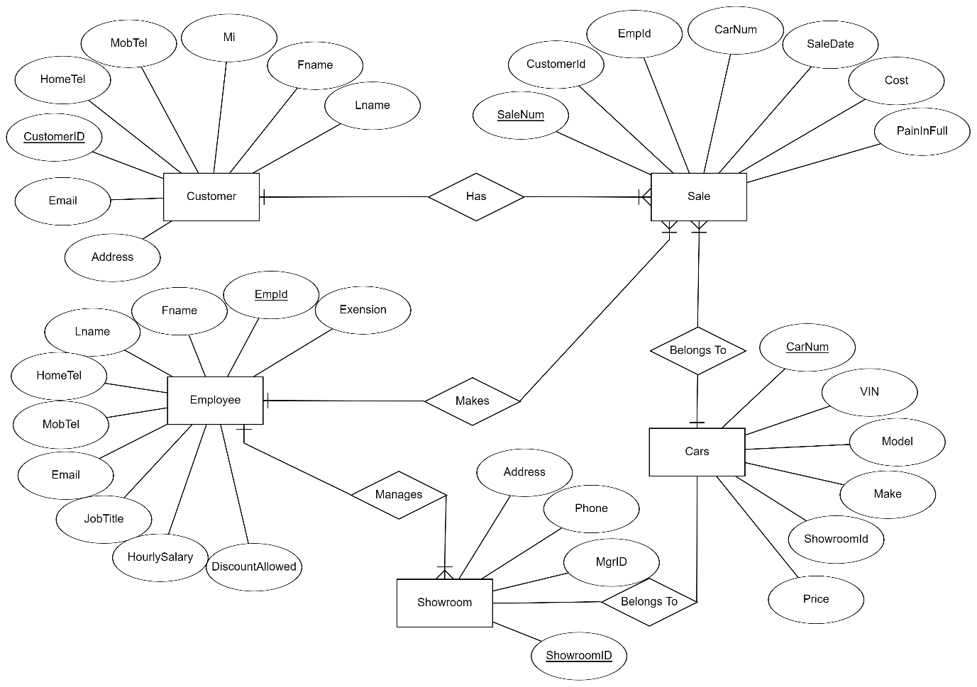

**Assumptions**

* **Not all employees can make a sale.**
* **Not all employees can manage a showroom**
* **Not all customers have a sale.**

# **Relational Schema**

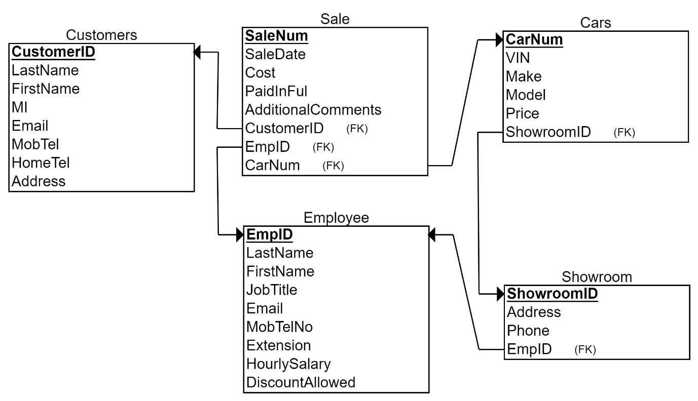

# **Creation of tables**

**Script**

|  |
| --- |
| **DROP TABLE sale CASCADE CONSTRAINTS;**  **DROP TABLE cars CASCADE CONSTRAINTS;**  **DROP TABLE employee CASCADE CONSTRAINTS;**  **DROP TABLE customers CASCADE CONSTRAINTS;**  **DROP TABLE showroom CASCADE CONSTRAINTS;**  **--create table employee**  **CREATE TABLE employee**  **(**  **empId NUMBER(10)CONSTRAINTS employee_empid_pk PRIMARY KEY,**  **lastName VARCHAR2(15),**  **firstName VARCHAR2(15),**  **job_title VARCHAR2(50),**  **email VARCHAR2(50),**  **mobTelNo VARCHAR2(10)CONSTRAINTS employee_mobtelno_nn NOT NULL,**  **HomeTel VARCHAR2(10),**  **extention VARCHAR2(32),**  **hourlySalary NUMBER(6,3),**  **discountAllowed NUMBER(3,2)**  **);**  **--create table customers**  **CREATE TABLE customers**  **(**  **customerID NUMBER(10)CONSTRAINTS customer_customerid_pk PRIMARY KEY,**  **lastName VARCHAR2(15),**  **firstName VARCHAR2(15),**  **mi VARCHAR2(10),**  **email VARCHAR2(50),**  **mobTel VARCHAR2(10)CONSTRAINTS customer_mobtel_nn NOT NULL,**  **homeTel VARCHAR2(10),**  **address VARCHAR2(30)CONSTRAINTS customer_address_nn NOT NULL**  **);**  **--create table showroom**  **CREATE TABLE showroom (**  **showroomID NUMBER(10)CONSTRAINTS showroom_showroomid_pk PRIMARY KEY,**  **MGRID NUMBER(10) CONSTRAINTS showroom_mgrid_fk REFERENCES employee(empId),**  **address VARCHAR2(30)CONSTRAINTS showroom_address_nn NOT NULL,**  **phone VARCHAR2(10)CONSTRAINTS showroom_phone_nn NOT NULL**  **);**  **--create table cars**  **CREATE TABLE cars**  **(**  **carNum NUMBER(10)CONSTRAINTS cars_carnum_pk PRIMARY KEY,**  **VIN VARCHAR2(50),**  **make DATE,**  **model VARCHAR2(20)CONSTRAINTS cars_model_nn NOT NULL,**  **Price NUMBER(8,3),**  **showroom_id NUMBER(10) CONSTRAINTS cars_showroom_fk REFERENCES showroom (showroomID)**    **);**  **--create table sale**  **CREATE TABLE sale**  **(**  **saleNum NUMBER(10)CONSTRAINTS sale_salenum_pk PRIMARY KEY,**  **customerID NUMBER(10) CONSTRAINTS sale_customerid_fk REFERENCES customers (customerID),**  **empID NUMBER(10)CONSTRAINTS sale_empid_fk REFERENCES employee (empId),**  **carNum NUMBER(10)CONSTRAINTS sale_carnum_fk REFERENCES cars (carNum),**  **saleDate DATE,**  **cost NUMBER(8,3),**  **paidInfFull VARCHAR2(30)CONSTRAINTS paid_nn NOT NULL,**  **additionalComments VARCHAR2(150)**  **);** |

# **Insertion of values into table**

**Script**

|  |
| --- |
| **INSERT INTO customers**  **VALUES (1,'Shahjahan','Haris','a123','haris@gmail.com','39647363','17117364','Manama Road 3720 House 977');**  **INSERT INTO customers**  **VALUES (2,'Hamdan','Malik','a124','Hamdan@gmail.com','32210087','17742279','Manama Road 3720 House 977');**  **INSERT INTO customers**  **VALUES (3,'Haider','Syed','a125','syed@gmail.com','39110022','17227456','Sitra Road 0914 House 113');**  **INSERT INTO customers**  **VALUES (4,'Costa','Alex','a126','Alex@ymail.com','39653411','17635242','Budaiya Road 1010 Villa 120');**  **INSERT INTO customers**  **VALUES (5,'Talaq','Yousuf','a127','yousuf@gmail.com','39635344','17003735','Sitra Road 1002 Villa 110');**  **--create into table employee**  **INSERT INTO employee**  **VALUES(1,'Ali','Ahmed','staff','Hamood@hotmail.com' ,'39655432','17790052',NULL,20.000,0.03);**  **INSERT INTO employee**  **VALUES(2,'Ameen','Ameena','manager','AmeenaAmeen@gmail.com','39211934','17435546',NULL,60.000,0.07);**  **INSERT INTO employee**  **VALUES(3,'Sadiq','Mahmood','admin','mahmood.admin@gmail.com','32210097','17233456',NULL,90.000,0.07);**  **INSERT INTO employee**  **VALUES (4,'Hussain','Huda','staff','dodo_bird@gmail.com','32110987','17112998',NULL,25.000,0.03);**  **INSERT INTO employee**  **VALUES (5,'Khalid','Isa','manager','IsaKhalid@gmail.com','32536647','17885034',NULL,50.000,0.07);**  **INSERT INTO showroom**  **VALUES(1,2,'Diplomatic Area','17520443');**  **INSERT INTO showroom**  **VALUES(2,5,'Riffa','17748839');**  **INSERT INTO cars**  **VALUES(1,'645372',TO_DATE('2014','YYYY'),'Toyota Yaris',2500.500,1);**  **INSERT INTO cars**  **VALUES(2,'830637',TO_DATE('2017','YYYY'),'Honda Civic',8000.300,1);**  **INSERT INTO cars**  **VALUES(3,'673632',TO_DATE('2013','YYYY'),'KIA RIO',3500.500,2);**  **INSERT INTO cars**  **VALUES(4,'718172',TO_DATE('2019','YYYY'),'Mazda 9',12500.500,2);**  **INSERT INTO cars**  **VALUES(5,'432424',TO_DATE('2012','YYYY'),'Lexus LS350',16500.500,2);**  **INSERT INTO cars**  **VALUES(6,'424632',TO_DATE('2014','YYYY'),'Toyota Camry',5500.500,2);**  **INSERT INTO cars**  **VALUES(7,'984324',TO_DATE('2018','YYYY'),'Nissan Maxima',8500,1);**  **INSERT INTO cars**  **VALUES(8,'234523',TO_DATE('2021','YYYY'),'Nissan Maxima',18500,1);**  **INSERT INTO cars**  **VALUES(9,'653567',TO_DATE('2020','YYYY'),'Infiniy Q80',23500,1);**  **INSERT INTO cars**  **VALUES(10,'245242',TO_DATE('2022','YYYY'),'Hyundai Sonata',8500,2);**  **INSERT INTO sale**  **VALUES(1,2,1,2,TO_DATE('13-04-2018','DD-MM-YYYY'),8000.300,'NO',NULL);**  **INSERT INTO sale**  **VALUES(2,1,4,4,TO_DATE('23-12-2019','DD-MM-YYYY'),12500.500,'NO',NULL);** |

# **Tables**

## Customers

## Employee

## Showroom

## Cars

## Sale

# **Functions**

## Check if employee functions

**Code**

|  |
| --- |
| **CREATE OR REPLACE FUNCTION employee_exists (id NUMBER )**  **RETURN BOOLEAN**  **IS**  **CURSOR emp_cur IS SELECT \***  **FROM employee**  **WHERE empid = id;**  **e_row emp_cur%ROWTYPE;**  **BEGIN**  **OPEN emp_cur;**  **Fetch emp_cur INTO e_row;**  **IF (emp_cur%found) THEN**  **RETURN true;**  **Else**  **RETURN false;**  **END IF;**  **END;** |

## Check if car exists

**Code**

|  |
| --- |
| **CREATE OR REPLACE FUNCTION car_exists (id NUMBER )**  **RETURN BOOLEAN**  **IS**  **CURSOR car_cur IS SELECT \***  **FROM cars**  **WHERE carnum = id;**  **c_row car_cur%ROWTYPE;**  **BEGIN**  **OPEN car_cur;**  **Fetch car_cur INTO c_row;**  **IF (car_cur%found) THEN**  **RETURN true;**  **Else**  **RETURN false;**  **END IF;**  **END;** |

## Check if a customer exits

**Code**

|  |
| --- |
| **CREATE OR REPLACE FUNCTION customer_exists (id NUMBER )**  **RETURN BOOLEAN**  **IS**  **CURSOR c_cur IS SELECT \***  **FROM customers**  **WHERE customerid = id;**  **c_row c_cur%ROWTYPE;**  **BEGIN**  **OPEN c_cur;**  **Fetch c_cur INTO c_row;**  **IF (c_cur%found) THEN**  **RETURN true;**  **Else**  **RETURN false;**  **END IF;**  **END;** |

## Check if showroom exists

**Code**

|  |
| --- |
| **CREATE OR REPLACE FUNCTION showroom_exists (id NUMBER )**  **RETURN BOOLEAN**  **IS**  **CURSOR shr_cur IS SELECT \***  **FROM showroom**  **WHERE showroomid = id;**  **sh_row shr_cur%ROWTYPE;**  **BEGIN**  **OPEN shr_cur;**  **Fetch shr_cur INTO sh_row;**  **IF (shr_cur%found) THEN**  **RETURN true;**  **Else**  **RETURN false;**  **END IF;**  **END;** |

## Check if employee is a manager

**Code**

|  |
| --- |
| **CREATE OR REPLACE FUNCTION is_manager (id NUMBER )**  **RETURN BOOLEAN**  **IS**  **CURSOR cur IS SELECT \***  **FROM employee**  **WHERE empid = id;**  **rec cur%ROWTYPE;**  **BEGIN**  **OPEN cur;**  **Fetch cur INTO rec;**  **IF (cur%found) THEN**  **IF UPPER(rec.job_title) = 'MANAGER' THEN**  **RETURN true;**  **ELSE**  **RETURN false;**  **END IF;**  **Else**  **RETURN false;**  **END IF;**  **END;** |

## Check if a car is sold

**Code**

|  |
| --- |
| **CREATE OR REPLACE FUNCTION car_sold (id NUMBER )**  **RETURN BOOLEAN**  **IS**  **CURSOR sale_cur IS SELECT \***  **FROM sale**  **WHERE carnum = id;**  **s_row sale_cur%ROWTYPE;**  **BEGIN**  **OPEN sale_cur;**  **FETCH sale_cur INTO s_row;**  **IF (sale_cur%found) THEN**  **RETURN true;**  **Else**  **RETURN false;**  **END IF;**  **END;** |

## Check if discount percentage is permitted

**Code**

|  |
| --- |
| **CREATE OR REPLACE FUNCTION discount_allowed (dis NUMBER, eid NUMBER )**  **RETURN BOOLEAN**  **IS**  **CURSOR cur IS SELECT \***  **FROM employee**  **WHERE empid = eid;**  **e_row cur%ROWTYPE;**  **BEGIN**  **OPEN cur;**  **FETCH cur INTO e_row;**  **IF e_row.discountallowed >= dis AND dis >= 0 AND dis <= 1 THEN**  **RETURN true;**  **ELSE**  **RETURN false;**  **END IF;**  **END;** |

## Apply a discount

**Code**

|  |
| --- |
| **CREATE OR REPLACE FUNCTION apply_discount (dis NUMBER, price NUMBER )**  **RETURN NUMBER**  **IS**  **final NUMBER;**  **BEGIN**  **final := price - (price*dis);**  **return final;**  **END;** |

# **Procedures (and sequences)**

## Customer

### Customer sequence

**Code**

|  |
| --- |
| **CREATE SEQUENCE customer_customerid_seq**  **START WITH 6;** |

### Procedure to add customer

**Code**

|  |
| --- |
| **CREATE OR REPLACE PROCEDURE insert_customer**  **(**  **lastname VARCHAR2,**  **firstname VARCHAR2,**  **mi VARCHAR2,**  **email VARCHAR2,**  **mobtel VARCHAR2,**  **hometel VARCHAR2,**  **address VARCHAR2**  **)**  **AS**  **BEGIN**  **INSERT INTO customers VALUES (customer_customerid_seq.nextval, lastname,**  **firstname, mi, email, mobtel, hometel, address);**  **COMMIT;**  **END;** |

### View for customer

**Code**

|  |
| --- |
| **CREATE OR REPLACE VIEW view_customer**  **AS SELECT customerid, lastname, firstname, mobtel, email FROM customers;** |

### Procedure to view customer

**Code**

|  |
| --- |
| **CREATE OR REPLACE PROCEDURE view_customer_info( id NUMBER ) IS**  **CURSOR c1 IS**  **SELECT * FROM view_customer**  **WHERE customerid = id;**  **c_rec c1%rowtype;**    **BEGIN**  **OPEN c1;**  **FETCH c1 INTO c_rec;**    **IF c1%NOTFOUND THEN**  **DBMS_OUTPUT.PUT_LINE('No customer with this ID');**  **ELSE**  **DBMS_OUTPUT.PUT_LINE('Customer id: ' || c_rec.customerid);**  **DBMS_OUTPUT.PUT_LINE('Customer name: ' || c_rec.firstname || ' ' || c_rec.lastname);**  **DBMS_OUTPUT.PUT_LINE('Mobile number: '||c_rec.mobtel);**  **DBMS_OUTPUT.PUT_LINE('Email '||c_rec.email);**  **END IF;**    **CLOSE c1;**  **END;** |

### Procedure to update customer

**Code**

|  |
| --- |
| **CREATE OR REPLACE PROCEDURE update_customer**  **(**  **id NUMBER,**  **first VARCHAR2,**  **last VARCHAR2,**  **mobile VARCHAR2,**  **home VARCHAR2,**  **e VARCHAR2,**  **m VARCHAR2,**  **adr VARCHAR2**  **)**  **IS**  **BEGIN**  **UPDATE customers**  **SET firstname = first, lastname = last, mobtel = mobile,**  **hometel = home, email = e, mi = m, address = adr**  **WHERE customerid = id;**  **COMMIT;**  **END;** |

### Procedure to delete a customer

**Code**

|  |
| --- |
| **CREATE OR REPLACE PROCEDURE delete_customer (id NUMBER) IS**  **BEGIN**  **DELETE FROM customers**  **WHERE customerid=id;**  **COMMIT;**  **END;** |

## Employee Functions

### Sequence for employee

**Code**

|  |
| --- |
| **CREATE SEQUENCE employee_empid_seq**  **START WITH 6;** |

### Procedure to add a new employee

**Code**

|  |
| --- |
| **CREATE OR REPLACE PROCEDURE insert_employee**  **(**  **lastname VARCHAR2,**  **firstname VARCHAR2,**  **jt VARCHAR2,**  **email VARCHAR2,**  **mobtel VARCHAR2,**  **hometel VARCHAR2,**  **ext VARCHAR2,**  **salary NUMBER,**  **discount NUMBER**  **)**  **AS**  **BEGIN**  **INSERT INTO employee VALUES (employee_empid_seq.nextval, lastname,**  **firstname, jt, email, mobtel, hometel, ext, salary, discount);**  **COMMIT;**  **END;** |

### Procedure to view employee

|  |
| --- |
| **CREATE OR REPLACE PROCEDURE view_employee( id NUMBER ) IS**  **CURSOR c1 IS**  **SELECT * FROM employee**  **WHERE empid = id;**  **e_rec c1%rowtype;**    **BEGIN**  **OPEN c1;**  **FETCH c1 INTO e_rec;**    **IF c1%NOTFOUND THEN**  **DBMS_OUTPUT.PUT_LINE('No employee with this ID');**  **ELSE**  **DBMS_OUTPUT.PUT_LINE('Employee id: ' || e_rec.empid);**  **DBMS_OUTPUT.PUT_LINE('Employee name: ' || e_rec.firstname || ' ' || e_rec.lastname);**  **DBMS_OUTPUT.PUT_LINE('Mobile number: '||e_rec.mobtelno);**  **DBMS_OUTPUT.PUT_LINE('Email: '||e_rec.email);**  **DBMS_OUTPUT.PUT_LINE('Hourly Salary: '||e_rec.hourlysalary);**  **DBMS_OUTPUT.PUT_LINE('Job title: '||e_rec.job_title);**  **DBMS_OUTPUT.PUT_LINE('Discount allowed: '||e_rec.discountallowed);**  **END IF;**    **CLOSE c1;**  **END;** |

### Procedure to update employee

**Code**

|  |
| --- |
| **CREATE OR REPLACE PROCEDURE update_employee**  **(**  **id NUMBER,**  **last VARCHAR2,**  **first VARCHAR2,**  **jt VARCHAR2,**  **e VARCHAR2,**  **mobtel VARCHAR2,**  **home VARCHAR2,**  **ext VARCHAR2,**  **s NUMBER,**  **d NUMBER**  **)**  **IS**  **BEGIN**  **UPDATE employee**  **SET lastname = last, firstname = first, job_title = jt, email = e, mobtelno = mobtel,**  **hometel = home, extention = ext, hourlysalary = s, discountallowed = d**  **WHERE empid = id;**  **COMMIT;**    **END;** |

### Procedure to delete employee

**Code**

|  |
| --- |
| **CREATE OR REPLACE PROCEDURE delete_employee (id NUMBER) IS**  **BEGIN**  **DELETE FROM employee**  **WHERE empid=id;**  **COMMIT;**  **END;** |

## Showrooms

### Sequence for showroom

**Code**

|  |
| --- |
| **CREATE SEQUENCE showroom_showroomid_seq**  **START WITH 3;** |

### Procedure to insert showroom

**Code**

|  |
| --- |
| **CREATE OR REPLACE PROCEDURE insert_showroom**  **(**  **MGRID NUMBER,**  **address VARCHAR2,**  **phone NUMBER**  **)**  **AS**  **BEGIN**  **INSERT INTO showroom VALUES (showroom_showroomid_seq.nextval, MGRID, address,phone);**  **COMMIT;**  **END;** |

### Procedure to update showroom

**Code**

|  |
| --- |
| **CREATE OR REPLACE PROCEDURE update_showroom**  **(**  **id NUMBER,**  **MID VARCHAR2,**  **adr VARCHAR2,**  **ph NUMBER**  **)**  **IS**  **BEGIN**  **UPDATE showroom**  **SET MGRID = MID, Address = adr, Phone = ph**  **WHERE showroomid = id;**  **COMMIT;**    **END;** |

### Procedure to view showroom

**Code**

|  |
| --- |
| **CREATE OR REPLACE PROCEDURE view_showroom( id NUMBER ) IS**  **CURSOR c1 IS**  **SELECT * FROM showroom**  **WHERE showroomid = id;**  **s_rec c1%rowtype;**    **BEGIN**  **OPEN c1;**  **FETCH c1 INTO s_rec;**    **IF c1%NOTFOUND THEN**  **DBMS_OUTPUT.PUT_LINE('No showroom with this ID');**  **ELSE**  **DBMS_OUTPUT.PUT_LINE('showroom id: ' || s_rec.showroomid);**  **DBMS_OUTPUT.PUT_LINE('MGRID: ' || s_rec.MGRID);**  **DBMS_OUTPUT.PUT_LINE('Address: '||s_rec.address);**  **DBMS_OUTPUT.PUT_LINE('Phone '||s_rec.phone);**  **END IF;**    **CLOSE c1;**  **END;** |

### Procedure to delete showroom

**Code**

|  |
| --- |
| **CREATE OR REPLACE PROCEDURE delete_showroom (id NUMBER) IS**  **BEGIN**  **DELETE FROM showroom**  **WHERE showroomid=id;**  **COMMIT;**  **END;** |

## Cars

### Sequence for car

**Code**

|  |
| --- |
| **CREATE SEQUENCE cars_carnum_seq**  **START WITH 11;** |

### Procedure to insert car

**Code**

|  |
| --- |
| **create or replace PROCEDURE insert_car**  **(**  **num NUMBER,**  **v VARCHAR2,**  **m DATE,**  **model VARCHAR2,**  **p NUMBER,**  **shid NUMBER**  **)**  **AS**  **BEGIN**  **INSERT INTO cars VALUES (num, v, m, model, p, shid);**  **COMMIT;**  **END;** |

### Procedure to view car

**Code**

|  |
| --- |
| **CREATE OR REPLACE PROCEDURE view_car( num NUMBER ) IS**  **CURSOR c1 IS**  **SELECT * FROM cars**  **WHERE carnum = num;**  **rec c1%rowtype;**    **BEGIN**  **OPEN c1;**  **FETCH c1 INTO rec;**    **IF c1%NOTFOUND THEN**  **DBMS_OUTPUT.PUT_LINE('No car with this car number');**  **ELSE**  **DBMS_OUTPUT.PUT_LINE('Vehicle Idantification Number: ' || rec.vin);**  **DBMS_OUTPUT.PUT_LINE('Make: ' || rec.make);**  **DBMS_OUTPUT.PUT_LINE('Model: '||rec.model);**  **DBMS_OUTPUT.PUT_LINE('Show room: '||rec.showroom_id);**  **END IF;**  **CLOSE c1;**  **END;** |

### Procedure to update car

**Code**

|  |
| --- |
| **CREATE OR REPLACE PROCEDURE update_car**  **(**  **num NUMBER,**  **v VARCHAR2,**  **m DATE,**  **model VARCHAR2,**  **p NUMBER,**  **shid NUMBER**  **)**  **IS**  **BEGIN**  **UPDATE cars**  **SET vin = v, make = m, model = m, price = p,showroom_id = shid**  **WHERE carnum = num;**  **COMMIT;**  **END;** |

### Procedure to delete car

**Code**

|  |
| --- |
| **CREATE OR REPLACE PROCEDURE delete_car (num NUMBER) IS**  **BEGIN**  **DELETE FROM cars**  **WHERE carnum=num;**  **COMMIT;**  **END;** |

### View to see only available cars (cars that are not sold)

**Code**

|  |
| --- |
| **CREATE OR REPLACE VIEW available_cars**  **AS SELECT * FROM cars**  **WHERE carnum NOT IN (SELECT carnum FROM sale);**  **-----------------------**  **SELECT * FROM available_cars;** |

## Sales

### Sales sequence

**Code**

|  |
| --- |
| **CREATE SEQUENCE salenum_seq**  **START WITH 3;** |

### Procedure to add a sale

**Code**

|  |
| --- |
| **CREATE OR REPLACE PROCEDURE insert_sale**  **(**  **cid NUMBER,**  **eid NUMBER,**  **cnum NUMBER,**  **paidinfull VARCHAR2,**  **cmt VARCHAR2,**  **dis VARCHAR**  **)**  **IS**  **price NUMBER := 0;**  **cost NUMBER := 0;**  **CURSOR c_cur IS**  **SELECT price FROM cars**  **WHERE carnum = cnum;**    **rec c_cur%rowtype;**  **BEGIN**    **IF NOT employee_exists(eid) THEN**  **DBMS_OUTPUT.PUT_LINE('No employee with this ID.');**    **ELSIF NOT customer_exists(cid) THEN**  **DBMS_OUTPUT.PUT_LINE('No customer with this ID.');**    **ELSIF NOT car_exists(cnum) OR car_sold(cnum) THEN**  **DBMS_OUTPUT.PUT_LINE('The car you entered is not available.');**    **ELSIF NOT discount_allowed(dis, eid) THEN**  **DBMS_OUTPUT.PUT_LINE('You either entered an invalid discount amount, or the employee can''t make this much of a discount.');**  **DBMS_OUTPUT.PUT_LINE('Make sure the discount amount is between 0 and 1.');**  **ELSE**  **OPEN c_cur;**  **FETCH c_cur INTO rec;**  **price := rec.price;**    **IF dis = 0 THEN**  **cost := price;**  **ELSE**  **cost := apply_discount (dis, price);**  **END IF;**    **INSERT INTO sale VALUES(salenum_seq.nextval, cid, eid, cnum, sysdate, cost, paidinfull, cmt);**  **COMMIT;**    **DBMS_OUTPUT.PUT_LINE('Your sale was recorded successfully');**    **END IF;**  **END;** |

### Procedure to view a sale

**Code**

|  |
| --- |
| **CREATE OR REPLACE PROCEDURE view_sale( num NUMBER ) IS**  **CURSOR c1 IS**  **SELECT * FROM sale**  **WHERE salenum = num;**  **rec c1%rowtype;**    **BEGIN**  **OPEN c1;**  **FETCH c1 INTO rec;**    **IF c1%NOTFOUND THEN**  **DBMS_OUTPUT.PUT_LINE('No sale with this ID');**  **ELSE**  **DBMS_OUTPUT.PUT_LINE('Sale number: ' || rec.salenum);**  **DBMS_OUTPUT.PUT_LINE('Customer ID: ' || rec.customerid);**  **DBMS_OUTPUT.PUT_LINE('Employee ID: '||rec.empid);**  **DBMS_OUTPUT.PUT_LINE('Car number: '||rec.carnum);**  **DBMS_OUTPUT.PUT_LINE('Sale date: '||rec.saledate);**  **DBMS_OUTPUT.PUT_LINE('Cost: '||rec.cost);**  **DBMS_OUTPUT.PUT_LINE('Paid in full: '||rec.paidinffull);**  **IF rec.additionalcomments IS NULL THEN**  **DBMS_OUTPUT.PUT_LINE('Additional comments: -');**  **ELSE**  **DBMS_OUTPUT.PUT_LINE('Additional comments: '||rec.additionalcomments);**  **END IF;**  **END IF;**  **CLOSE c1;**  **END;** |

# **Form triggers**

## Check employee discount for manager

**Code**

|  |
| --- |
| **CREATE OR REPLACE EDITIONABLE TRIGGER "EMPLOYEE_DISC"**  **BEFORE**  **insert or update on "EMPLOYEE"**  **for each row**  **BEGIN**  **IF UPPER(:NEW.job_title) = 'MANAGER' THEN**  **IF :NEW.discountallowed > 0.07 OR :NEW.discountallowed < 0 THEN**  **RAISE_APPLICATION_ERROR(-20001, 'Invalid manager discount amount.');**  **END IF;**  **END IF;**  **END;** |

## Check employee discount for staff

**Code**

|  |
| --- |
| **CREATE OR REPLACE EDITIONABLE TRIGGER "STAFF_DISC"**  **BEFORE**  **insert or update on "EMPLOYEE"**  **for each row**  **BEGIN**  **IF UPPER(:NEW.job_title) = 'STAFF' THEN**  **IF :NEW.discountallowed > 0.03 OR :NEW.discountallowed < 0 THEN**  **RAISE_APPLICATION_ERROR(-20002, 'Invalid staff discount amount. Should be less than 0.03%-');**  **END IF;**  **END IF;**  **END;** |

## Trigger for car number

**Code**

|  |
| --- |
| **CREATE OR REPLACE EDITIONABLE TRIGGER "CAR_NUM"**  **BEFORE**  **insert on "CARS"**  **for each row**  **BEGIN**  **IF car_exists(:NEW.carnum ) THEN**  **RAISE_APPLICATION_ERROR(-20003, 'A car with this car number already exists.');**  **END IF;**  **END;** |

## Trigger to check showroom id

**Code**

|  |
| --- |
| **CREATE OR REPLACE EDITIONABLE TRIGGER "CHECK_SHOWROOM"**  **BEFORE**  **insert or update on "CARS"**  **for each row**  **BEGIN**  **IF NOT showroom_exists(:NEW.carnum ) THEN**  **RAISE_APPLICATION_ERROR(-20004, 'Invalid showroom ID.');**  **END IF;**  **END;** |

## Trigger to check if manager exists

**Code**

|  |
| --- |
| **CREATE OR REPLACE EDITIONABLE TRIGGER "CHECK_MANAGER"**  **BEFORE**  **insert or update on "SHOWROOM"**  **for each row**  **BEGIN**  **IF NOT is_manager(:NEW.mgrid ) THEN**  **RAISE_APPLICATION_ERROR(-20006, 'No manager with this ID.');**  **END IF;**  **END;** |

## Trigger to insert employee

**Code**

|  |
| --- |
| **CREATE OR REPLACE EDITIONABLE TRIGGER "AUTO_EMP"**  **BEFORE**  **insert or update on "EMPLOYEE"**  **for each row**  **BEGIN**  **IF :NEW.empid IS NULL THEN**  **SELECT employee_empid_seq.nextval**  **into :NEW.empid from sys.dual;**  **END IF;**  **END;** |

## Trigger to insert customer

**Code**

|  |
| --- |
| **CREATE OR REPLACE EDITIONABLE TRIGGER "AUTO_CUST"**  **BEFORE**  **insert or update on "CUSTOMERS"**  **for each row**  **BEGIN**  **IF :NEW.CUSTOMERID IS NULL THEN**  **SELECT customer_customerid_seq.nextval**  **into :NEW.CUSTOMERID from sys.dual;**  **END IF;**  **END;** |

## Trigger to insert car

**Code**

|  |
| --- |
| **CREATE OR REPLACE EDITIONABLE TRIGGER "AUTO_CAR"**  **BEFORE**  **insert or update on "CARS"**  **for each row**  **BEGIN**  **IF :NEW.CARNUM IS NULL THEN**  **SELECT cars_carnum_seq.nextval**  **into :NEW.CARNUM from sys.dual;**  **END IF;**  **END;** |

## Trigger to insert sale

**Code**

|  |
| --- |
| **CREATE OR REPLACE EDITIONABLE TRIGGER "AUTO_SALE"**  **BEFORE**  **insert or update on "SALE"**  **for each row**  **BEGIN**  **IF :NEW.SALENUM IS NULL THEN**  **SELECT salenum_seq.nextval**  **into :NEW.SALENUM from sys.dual;**  **END IF;**  **END;** |

# **Login accounts**

1. **Customer**

|  |  |
| --- | --- |
| **Haris** | **123** |
| **Malik** | **123** |
| **Syed** | **123** |

1. **Staff**

|  |  |
| --- | --- |
| **Ahmed** | **123** |
| **Huda** | **123** |

1. **Manager**

|  |  |
| --- | --- |
| **Ameena** | **123** |
| **Isa** | **123** |

# **Application screenshots**

## Customer

1. **Home page**



1. **Edit account**

1. **View available cars**

## Staff

1. **Home page**



1. **Manage Account**

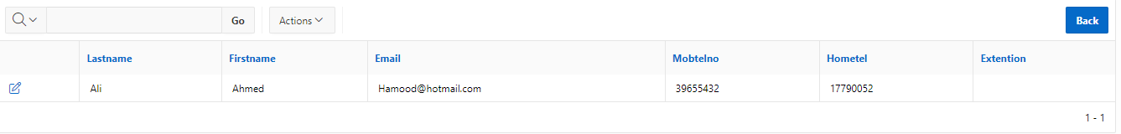

1. **Manage Cars**

1. **Sell car**

1. **Sell car with discount**

1. **Add customer**

1. **View sales by customer (Top customer, bottom sale)**

## Admin

1. **Admin home**



1. **Manage Employees (View, Edit, Delete, Add)**

1. **Manage Showrooms that you own (Create, Edit, Delete)**

1. **Manage Cars that you own (Create, Edit, Delete)**

